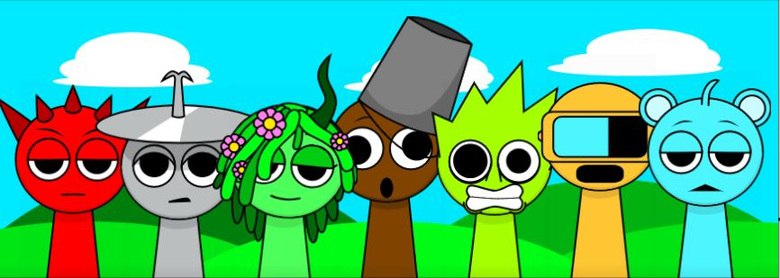

What is Sprunki Game?

[Sprunki Game](https://sprunki-game.io/) is a puzzle and adventure video game created by a creative team who want to provide players with moments of relaxation and enjoyment. The game revolves around gorgeous characters known as Sprunki, each of them have unique powers that help players solve game problems.

## Vivid graphics and sound

The vivid and brilliant graphics in Sprunki Game are one of its best features. The characters are made in a pleasant cartoon style and paired with a vibrant scene to create a fascinating Sprunki universe. The game's sound is likewise well-designed, with joyful background music and colorful sound effects that let players immerse themselves in each level.

## Gameplay is unique and attractive

Sprunki Game offers easy but hard gameplay. To fulfill the mission, players will guide Sprunki characters over obstacles, riddles, and gather items. Each character in the game has unique skills, such as jumping high, flying quickly, or releasing electric rays, which allow players to be adaptable when tackling problems.

## Lovely Characters

The characters in Sprunki Game are essential to the game's popularity. Each character has its own personality, from the active Sprunki to the amusing Bouncy, the smart Zappy, the agile Whizzy, and the humorous Giggle, adding variety and enjoyment to the game. Players can team up with their favorite characters to go on adventures in the Sprunki realm.

## Community and Competition

Sprunki Game is not only a basic pleasure game, but also a hub for the player community. With a range of game modes ranging from single player to competitive play, players may compete with friends or take part in special events to earn valuable rewards. Rankings and personal achievements are also variables that encourage competitiveness, allowing participants to constantly improve their abilities.

## Why should you play the Sprunki Game?

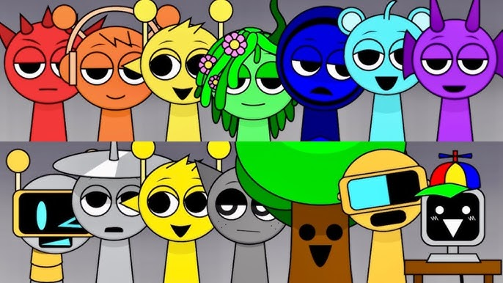

Healthy entertainment: The Sprunki Game is appropriate for all ages, providing moments of relaxation and refreshing laughter.

Training thinking: The stages test agility and puzzle-solving abilities, allowing players to learn logical reasoning.

Connecting with the community: Join Sprunki Game to meet and compete with other players that share your passion.

# Conclusion

Sprunki Game is a bright and visually appealing entertainment game that is ideal for all players. With stunning graphics, interesting gameplay, and adorable characters, Sprunki Game promises to provide hours of fun. Download Sprunki Game and start exploring the amazing world of Sprunki today!

# Join the Sprunki Game community!

Experience a new role with Sprunki Game as you express your new musical creations. Accompany Sprunki characters and express your own melodic emotions.

* [Website](https://sprunki-game.io)
* [Reddit](https://www.reddit.com/user/Ashamed-Ad-3020/)
* [X](https://x.com/SprunkiGame00)
* [Pinterest](https://www.pinterest.com/sprunkigamesocial/)
* [YouTube](https://www.youtube.com/@sprunkigamesocial)